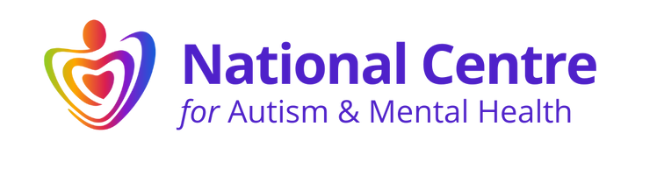
REGISTRATION FORM FOR ENTRY INTO THE NCAMH DIRECTORY

PRACTITIONERS DIRECTORY REGISTRATION FORM

Name
Practitioner role (provide details)
Address
E-mail address
Phone number
How did you hear about the NCAMH Practitioners Directory?
What level of entry are you seeking in the Practitioners Directory? | PLEASE PROVIDE A TICK IN THE BLANK BOX NEXT TO THE LEVEL OF ENTRY YOU ARE SEEKING IN THE PRACTITIONERS ‘DIRECTORY
Associate level (to complete Modules 1 and 2)
You can purchase these modules directly online via the training and events page, please click here for more information.

Approved member level (to complete the BPS Approved Certificate in Autism and Mental Health).
You can purchase the Certificate directly online via the training and events page, please click here for more information.
For an invoice to be raised please provide details below of where we should send the invoice.

Fellow member level (to complete the BPS Approved Diploma in Autism and Mental Health)
Please provide details below of where the invoice for the course should be sent.

Contact name for the invoice:
E-mail address for where the training invoice needs to be sent (if not purchasing directly on-line)
Signature
Date

THANKYOU FOR COMPLETING THE FORM
PLEASE RETURN BY E-MAIL TO: hello@ncamh.co.uk
Any queries please call: 07545 190915

